Divisional Forest Officer, Ghumsur North Forest Division

Request for Proposal (RFP) FOR
Selection of an agency for development of Ecotourism site at Blackbuck Nature Camp, Dam Site, Bhanjanagar on Turnkey basis
Quality & Cost Based Selection (QCBS)

February 2026

Divisional Forest Officer,
Ghumsur North Forest Division,
Bhejiput, Bhanjanagar,
Ganjam, Odisha -761126

Divisional Forest Officer
Ghumsur North Division

Contract Data

- GENERAL INFORMATIONS

Sl.  No. | Item | Details
1 | Name of the Work | Selection of an agency for Holistic development of Ecotourism site Blackbuck Nature Camp, Dam Site, Bhanjanagar on Turnkey basis with estimated cost Rs.2.78 Crore (Approx).
2 | Name of First Party | Divisional Forest Officer, Ghumsur North Division.

- BID INFORMATION

1 | Intended completion period/ Time period  assigned for Completion | 40 days
2 | Cost of Bid Documents | INR 10,000/-  Demand Draft in favour of “Divisional Forest Officer, Ghumsur North Division.”  Bid should accompany with DD.
3 | Bid Security | INR 1,00,000/- as EMD.  Bank security in favour of “Divisional Forest Officer, Ghumsur North Division.”
4 | Performance security | INR 5% in the form of Bank Guarantee /  Bank draft / TDR of the total value
5 | Bid validity period | 30 days
6 | Currency of Contract | Indian Rupee
7 | Language of Contract | English
8 | Bid documents such as DTCN / BOQ etc.  can be seen / downloaded from the Govt. Website | https://ganjam.nic.in / https://www.wildlifeodisha.in/  https://odishaforest.in
9 | Due date for tender submission | 15.02.2026 at 04.30 PM
10 | Opening of the technical bid | 16.02.2026 at 10.30 AM
11 | Technical presentation | 16.02.2026 at 11.30 AM
12 | Opening of Financial Bid | 16.02.2026 at 04.30 PM

Divisional Forest Officer
Ghumsur North Division

Contents
- Indicative Layout of Eco-Tourism Site 4
- Illustrative images for development of Eco-Tourism site 4
- Description of Work to be carried out for development of ‘Ecotourism site at Black Buck Nature Camp, Dam Site, Bhanjanagar 6
- Scope of Work 7
- Deliverables and Timelines 8
- Minimum eligibility criteria 9
- Submission of proposal: Packing, Sealing and Marking of proposals 11
- Brief description of the selection process 12
  - Step-1 Technical Proposal 12
  - Step 2 Financial Proposal- 13
- Bid Evaluation Process 14
- Performance Security 14
- Forfeiting of Bid Security 14
- Payment Terms 15
- Penalty for delay 16
- Defect Liability Period 16
- Jurisdiction of Court 16
- Instruction to Agency 16
Annexure 1 Covering letter (on the letter-head of the agency) 18
Annexure II - Financial Proposal
Annexure III Proforma for bank guarantee for performance security 19
ANNEXURE IV DRAFT AGREEMENT 21

1. GPS coordinates of the locations are given below: -
- GPS coordinates of the site to be developed.
1 | Activity area | 19°57'46.5"N 84°34'17.6"E
2 | Parking area | 19°57'51.8"N 84°34'09.0"E
3 | Cottage | 19°57'46.7"N 84°34'17.2"E
4 | Landscape area | 19°57'47.4"N 84°34'18.7"E
5 | Landscape area 2 | 19°57'49.0"N 84°34'18.1"E
6 | Watch tower | 19°57'47.9"N 84°34'19.0"E
7 | Community hall | 19°57'52.3"N 84°34'11.9"E
8 | Canopy walk | 19°57'50.8"N 84°34'17.6"E

2. Illustrative images for development of Ecotourism Site: -

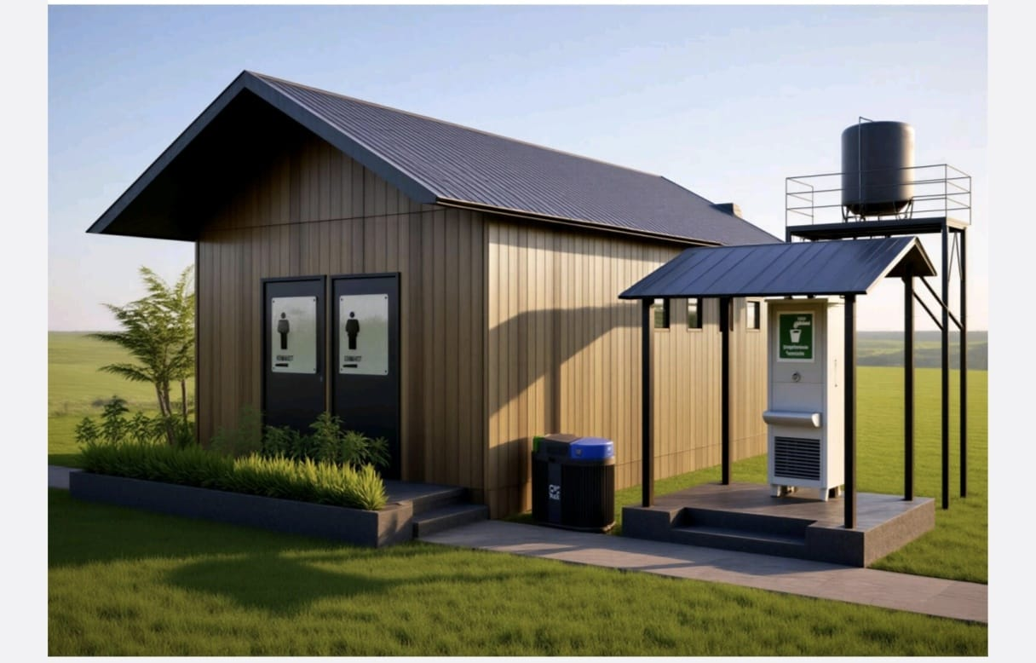

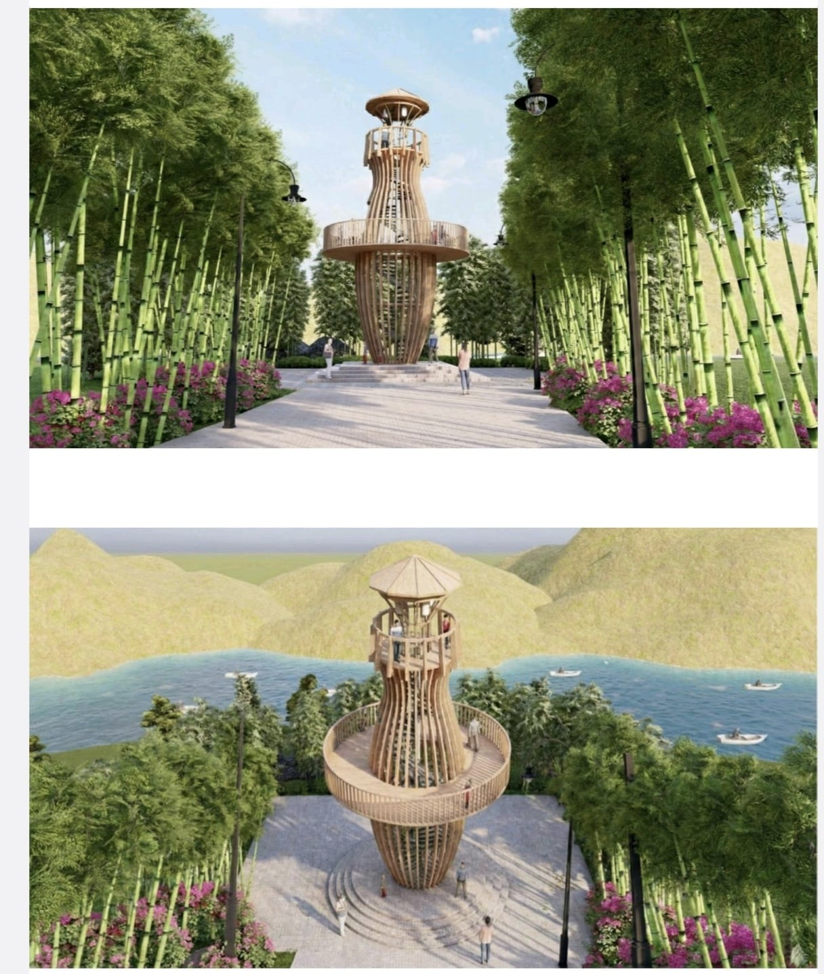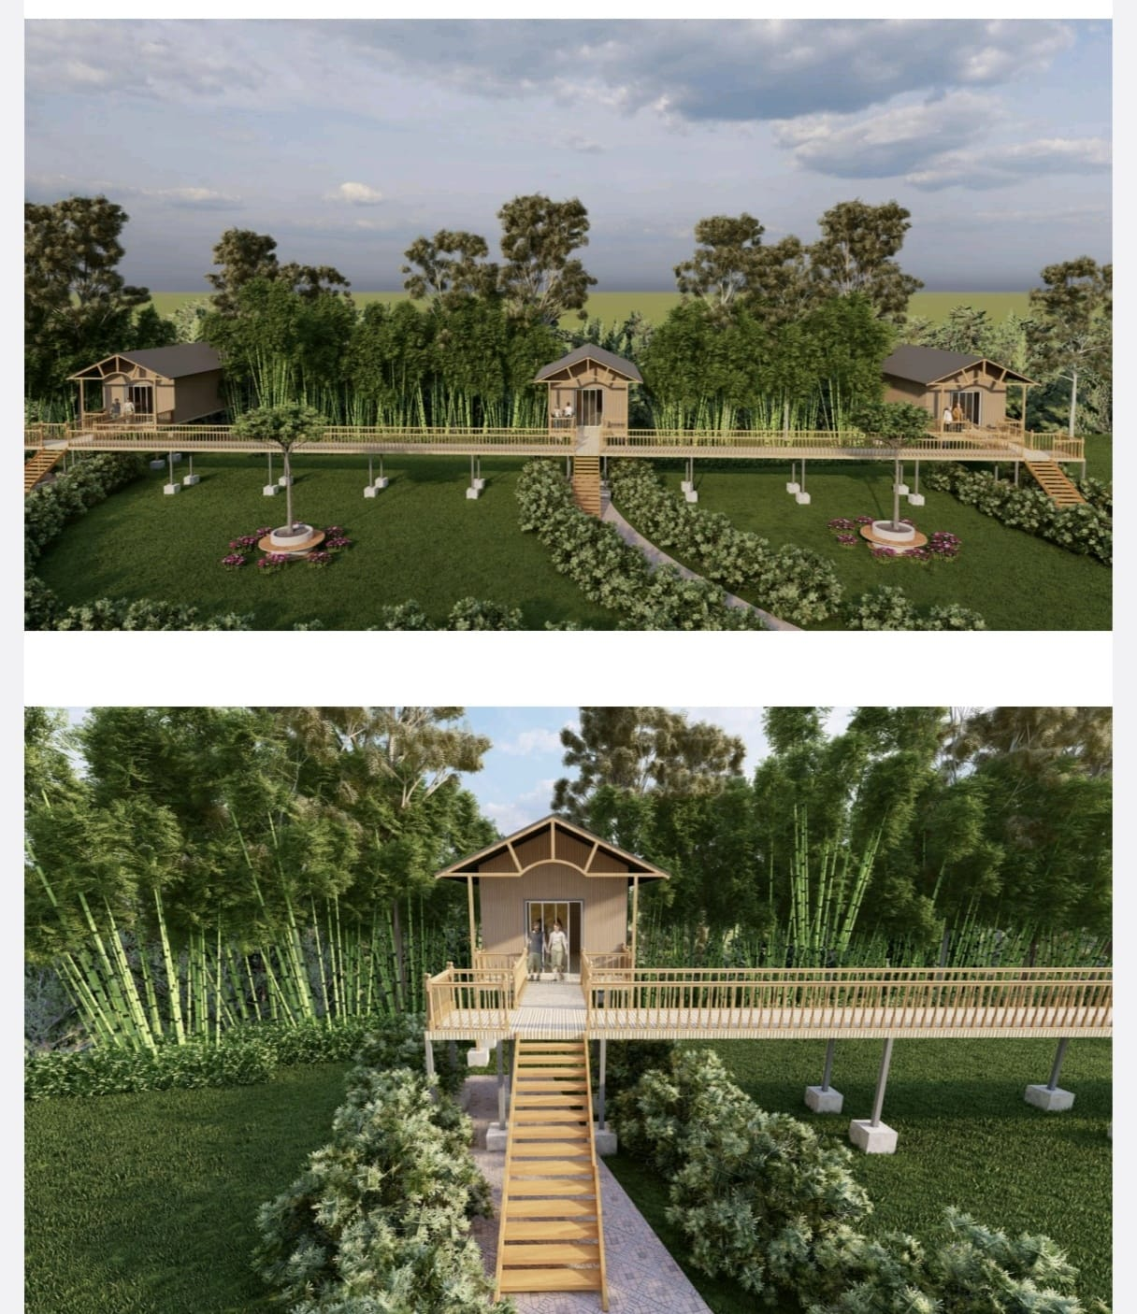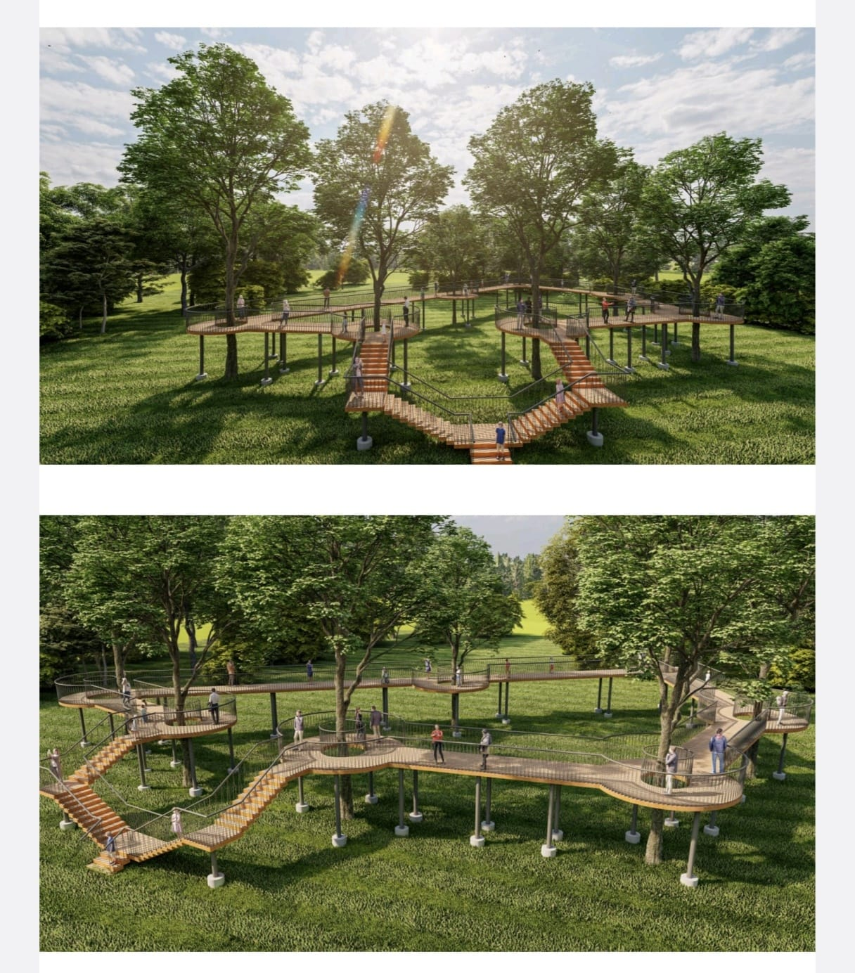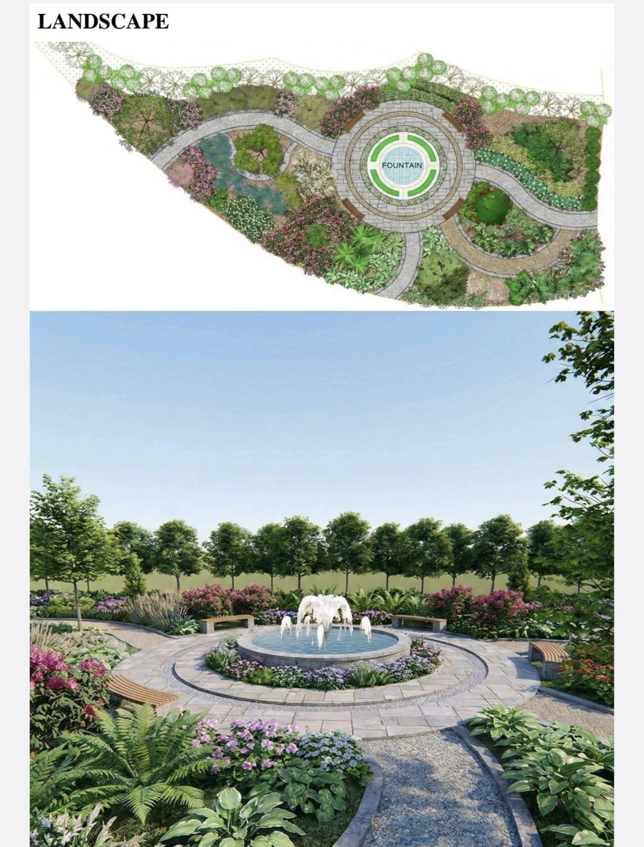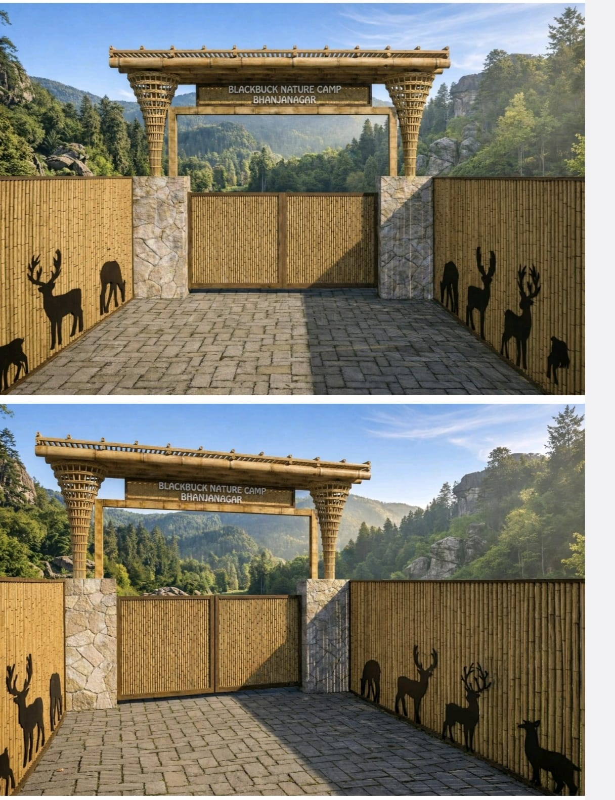

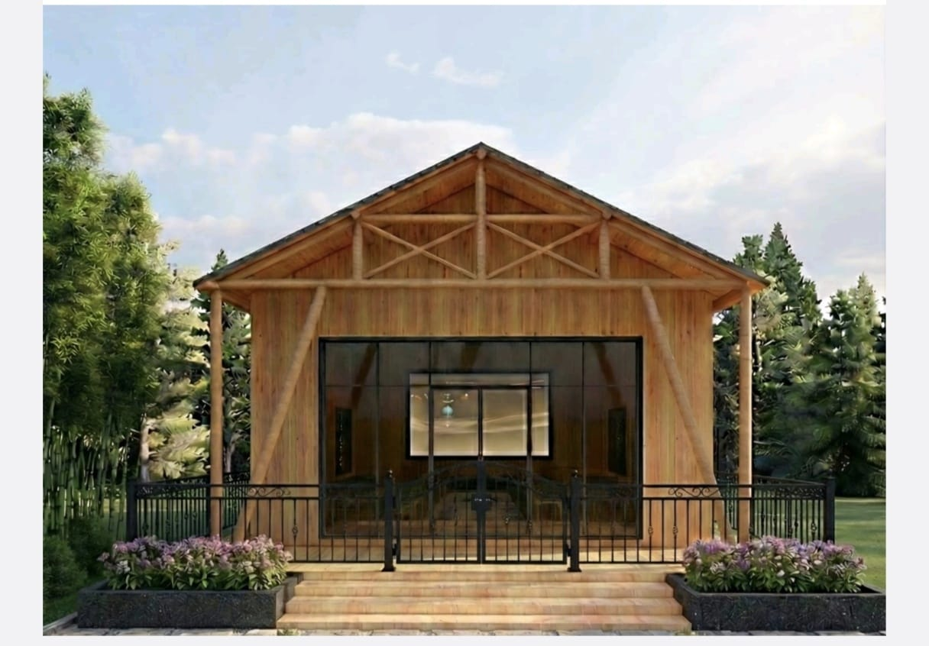

2. A Tentative component wise work to be executed: -

Sl No. | Activity/Component | Estimated/Approx Cost (in Rs.)
1 | Wooden Cottage 3 nos. | 8125331.45
2 | Cottage Connecting Corridor | 1737176.68
3 | Construction of Entry Gate | 795595.94
4 | Construction of Iron Watch Tower | 4165023.33
5 | Construction of overhead Tank having 5000 Ltr. Capacity | 280000.00
6 | Construction of Canopy Walk | 3476886.78
7 | Landscaping | 1105930.82
8 | Signage | 398800.00
9 | Pavers Block in path | 1229332.35
10 | Upgradation of exiting Public Toilet (2 Nos.) | 62000.00
11 | Construction of new Public Toilet (2 Nos.) | 688001.40
12 | Parking Lot (1 No.) | 237276.00
13 | Construction of Community Hall (1 No.) | 4049766.88
14 | Construction of Driver shed | 581062.02
15 | Area enlargement and Development | 840803.70
 | Grand Total | 27772987.00

Note: - The extra amount if any in any of the component can be used for other component. Keeping entire project cost at Rs.2,77,72,987/- (Two crores seventy-seven lakhs seventy-two thousand nine hundred eighty-seven rupees) excluding profit and all govt taxes, levies and liabilities.

3. Description of Work to be carried out for development of Ecotourism site at Black Buck Nature Camp, Dam Site, Bhanjanagar
The agency is expected to develop the Ecotourism site holistically observing the surroundings. All the natural elements including trees should be considered into the design. No Cutting of trees will not be allowed for the development of the Ecotourism site.

- The Agency should incorporate the rules / guidelines related to Forest Conservation Act of Eco tourism sites while constructing.

Important requirements–
- The structures must withstand extreme conditions like cyclones, extreme heat, corrosion etc,
- It should have provisions for dismantling on a short notice in case of any emergency and the Executing Agency has to provide support for next 5 years.
- The agency must make sure for no permanent structures for the development of the Ecotourism site i.e. any structure, damaging the existing bio-diversity area of the area.

4. Scope of Work The broad scope of work is as mentioned below-

Execution of works
  - Deploy required manpower/ labour for transport of material and execution at site
  - Supervision and monitoring of work on daily basis.
  - Preparation of weekly progress reports after start of execution work
  - Joint inspection with Divisional Forest Officer and officials of Forest Department during and post execution.
  - Submission of “as built drawings” with proposed v/s executed images of execution work.
  - At the time of Execution maximum care to be taken to reduce the impact of biodiversity in that area.
  - The bidder should provide at least 2 years warranty for prefabricated structures and up to 5 years maintenance support.
5. Timelines

Sl | Deliverables | Details | Timeline
1 | Execution work | Submission of Weekly progress report based on execution | T1 + 40 Days (Timeline for execution shall start after approval from DFO, Ghumsur North and when the executing contractor selected by agency is on board)

T1*- Date of start of execution of work

- Work should be completed in the time mentioned. No extension of time line permitted.

6. Minimum eligibility criteria

Technical eligibility

  - Bidder must be a registered firm (Pvt. Ltd., LLP, Proprietorship, Partnership) with minimum 3 years of experience of executing Govt of Odisha projects, preferably Tourism Dept projects with project value of at least 1.5 crores. (One crore and Fifty lakh rupees) based on temporary prefabricated structures.

  - Read Technical Presentation and Evaluation criteria (Page No.13), if the bidder has executed Govt project, maximum of 5 marks per project will be awarded and for private resort projects maximum of 2.5 marks per project will be awarded, for a maximum of 2 projects during technical evaluation.

  - Must have experience in –
    - Execution of at least 3 commercial projects with temporary structures (cottages/ restaurants/ luxury tree house etc) on turnkey basis in the last 3 years.
    - Temporary structures like prefabricated structures/ containers/ pergolas etc. (No permanent concrete structures shall be considered applicable).
    - Must have executed project on turnkey basis with temporary structures with minimum built up area of 2500 Sq. Ft.

Note-

- Work orders and completion certificates for completed projects to be furnished along with proposed Images v/s executed project images.
- In case the agency is an Architecture and Planning agency, the details of associates/ Sub-consultants/ Contractors/ Sub-contractors for provision of temporary structures (prefabricated structures/ containers/ pergolas etc) must be furnished. The work orders and completion certificates of the same may be considered along with the technical eligibility criteria.
- One credential/ engagement may be submitted to prove eligibility on multiple unique criteria by Bidders for satisfying the technical eligibility criteria

Financial eligibility

  - Average Annual Turnover of INR 1.0 Cr. in last 3 financial years. Auditor certificate and audited financials to be furnished.
  - Must have positive net worth as on January’ 2026. Auditor/ CA certificate to be furnished.
  - Must be registered with GSTIN. GST registration certificate to be furnished.
  - Should not be blacklisted from any Govt. agency / department/ PSU for any malpractices. (Undertaking should be submitted)

7. Submission of proposal: Packing, Sealing and Marking of proposals:

The submission of the proposal shall be done in a single large envelope which shall consist of 2 envelopes Part A and Part B

Part A (offline)

TECHNICAL PROPOSAL for “Selection of an agency for development of Ecotourism site at Black Buck Nature Camp, Dam Site, Bhanjanagar on Turnkey basis”

The Envelope Part A must be clearly super scribed with the following:

TECHNICAL PROPOSAL
For

Selection of an agency for development of Ecotourism site at Black Buck Nature Camp, Dam Site, Bhanjanagar on Turnkey basis”

Part B (offline)

FINANCIAL PROPOSAL for “Selection of an agency for development of Ecotourism site at Black Buck Nature Camp, Dam Site, Bhanjanagar on Turnkey basis”

The agency’s Name & Address shall be mentioned in the left-hand bottom corner of the outer large envelope.

- The envelope shall be addressed to Divisional Forest Officer, Ghumsur North Division at the following Address:

Divisional Forest Office,

Ghumsur North Forest Division,

Bhejiput, Bhanjanagar,

Dist-Ganjam-761126.

- If the envelope is not sealed and marked as mentioned above, then DoT will assume no responsibility for the Proposals being misplaced or opened pre- maturely.

Note:
- The proposals shall be typed or written in indelible ink and shall be signed by the authorized signatory of the empaneled agency.
- Any interlineations, erasures or overwriting shall be valid only if they are initiated by the person signing the Proposal prior to submission of the Proposal.
- The Tender will be received in closed cover in the tender box kept in the chamber of Section Officer, Ghumsur North Division till 4.30 PM of 12.02.2026.
- The Divisional Forest Officer, Ghumsur North Division may withdraw the tender at any time without citing any reasons thereof.
8. Brief description of the selection process

The evaluation of the proposal will be completed in 2 steps-
  - Step-1 Technical Proposal
  - Step 2- Financial Proposal
Evaluation of the bids will be based on Quality cum Cost Based Selection (QCBS) mode with weightage of 70% and 30% for technical proposal and financial proposal respectively.

8.1 Step-1 Technical Proposal

The interested agencies must submit the following with the technical proposal
  - Details of agency
  - Details of similar executed projects as mentioned in Technical eligibility criteria
  - Conceptual plan and methodology for execution work specifying various components and sub-components.

Note-:
  - Drawings (indicative scale) must be prepared on software such as Auto CAD, REVIT, 3DMax, Google Sketchup, Corel draw, photoshop etc.
  - Illustrations can be submitted in the form of sketches, 3D views etc.

Method of submission
The submission must be done in the form of soft copy as well as hard copy.
  - Soft copies shall be emailed to dfo.ghumsurnorth@odisha.gov.in in the .dwg, .pdf, .jpeg, .doc, .pptx etc.
  - Hard copies (colour prints) must be submitted in A2 size sheets
Note- The eligible agencies may be called for a technical presentation as per the date mention in Contract Data of the concept plan submitted. Details of technical presentation are given below

Technical presentation Evaluation Criteria for each location

S.no. | Parameters | Maximum Marks
1 | Experience in execution of Tourism Project with temporary structures prefabricated structures/ containers/ pergolas etc. (Per project – 5 Marks) (maximum 10 marks)  (For Govt. project maximum marks- 5, for private project maximum marks- 2.5)  - Similar work with details of area, nature of work etc-2 marks  - Details of unique components proposed-2 marks  - Proposed v/s actual images of projects executed-3 marks  - Cost of project executed (>1.0 crore)- 3 marks | 20
2 | Technical presentation on understanding and work methodology of the assignment and conceptual plan for timely execution of the project adhering to all the guidelines mentioned in the DTCN. | 30
3 | Details of proposed vendors/ sub consultants for temporary  structures (prefabricated structures/ containers/ pergolas etc.) with executed project images and work completion certificate from the Agency. | 20
Total |  | 70

8.2 Step 2 Financial Proposal-:

The financial bids of shortlisted agency’s scoring at least 70% marks in the technical proposal (Agencies those score minimum 70% marks in the technical proposal i.e. ≥49 out of 70 marks) will be considered for financial proposal opening.

Preparation of financial proposal

While preparing the financial proposal, the agencies are expected to consider the requirements and conditions as per the tender document.

- The financial proposal shall be quoted in lump sum amount (project cost including consultancy charges, for “Selection of an agency for Execution for development of Ecotourism site at Black Buck Nature Camp, Dam Site, Bhanjanagar on Turnkey basis” shall be submitted in support envelope.
- All taxes and surcharges as applicable shall be paid by the selected agency.
- Final quote should be inclusive of out of pocket expenses.

9. Bid Evaluation Process

- Technical Score-: The total score obtained by the agencies as per the technical proposal shall be the technical score (Ts) of the agencies.
- Financial Score-: The financial bid of the agency would be opened after evaluation of technical bid. The lowest financial proposal will be given a financial score (Fs) of 30 points. The financial scores of other proposals will be computed as follows:

Fs=30XFM1/F1

(F1=amount of Financial Proposal as quoted by the Agency; FM 1= Lowest financial quote)

Combined and Final Evaluation-:
Combined score shall be calculated based on Technical and financial scores of the Agency as per QCBS system. Proposals will finally be ranked according to their combined Score (S) calculated based on technical (Ts) and financial (Fs) scores as follows:

S= Ts+Fs
The financial proposal quoted by the agency should be inclusive of all cost, taxes, profit, levies and legal liabilities. IT TDS and GST TDS will be deducted by the first party.
- Selection of agency
The Agency securing the highest combined score would be the Selected Agency. The Second and third Ranked Agency shall be kept in reserve and may be invited for negotiations in case the first ranked Agencies withdraws or fails to comply with the requirements specified in the RFP document.

10. Performance Security
Within 15 days of receipt of the Letter of Acceptance, the successful Agency shall deliver to the Employer a Performance Security for an amount equivalent to 5% of the Contract price in the form of Bank Guarantee from a Nationalized Bank of India / Bank draft / TDR duly pledged in favor of Divisional Forest Officer, Ghumsur North. The performance security will be released after completion of defect liability period.

11. Forfeiting of Bid Security
Failure to drawl of agreement after issuance of LOA or misleading the authority by false statement at any stage, there will be forfeiture of the Bid Security.

12. Payment Terms

Sl | Deliverables | Payment terms
1 | Preparation of DPR | 1% of project cost earmarked for consultancy agency towards preparation of DPR.
2 | Execution | 35% on completion of structure after certification by an independent 3rd party.
2 | Execution | 40% on completion of furnishing and other accessories. After certification by an independent 3rd party.
2 | Execution | 24% on approval of Third party (or) any other Agency appointed on this behalf.

- Independent 3rd party means any Govt. Engineer of at least Executive Engineer rank (or) any authorised agency by Govt. of India / Odisha to certify similar kind of works.

13. Penalty for delay

0.05% of contract value per day up to maximum up to 5% of contract value beyond contract period.

14. Defect Liability Period

Any defects, shrinkage or other faults which may be noticed within 18 (Eighteen) months from the completion of the work arising out of defective or improper materials or workmanship and made good by the contractor at his own cost failure of which the Department may recover from the contractor the cost of making good the works. The performance security will be released after completion of defect liability period.
The Agency shall submit ‘As built drawings’ to DFO, Ghumsur North after the execution of work has been completed. Additionally, the Agency shall also submit to Divisional Forest Officer, Ghumsur North the O&M manual and guarantee/warranty cards of all the components and sub-components installed.
15. Jurisdiction of Court

Dispute / Litigation if any, arising out of this contract deemed to have been entered into shall be under the jurisdiction of Orissa High Court.
16. Instruction to Agency

- The first party shall hold the right to increase/decrease the Estimated cost mentioned in Tentative component 2.A of Tentative component wise work to be executed, as per field requirement.
- The first party shall hold the right to omit / add any specific component mentioned in Tentative component wise break up of work to be executed, as per field requirement.

ANNEXURE 1 Covering letter (on the letter-head of the agency)
Date:

To,
The Divisional Forest Officer,
Ghumsur North Forest Division,
Bhejiput, Bhanjanagar,
Ganjam-761126

Subject: “RFP for Selection of an agency for Execution of Holistic development of Ecotourism site at Black Buck Nature Camp, Dam Site, Bhanjanagar on Turnkey basis”
Sir,
In response to your invitation for the tender for the captioned subject matter, we are submitting our technical proposal and financial proposal in the prescribed format.

Thanking you,

Yours sincerely,

(Name, Signature and Company seal)

Address of Communication

Annexure II Proforma for bank guarantee for performance security
(ON NON-JUDICIAL STAMP PAPER OF Rs.100/-)

Ref Date Bank Guarantee No:

In accordance with invitation to Tender Notice No._ _ Dated or RFP for Selection of an agency for development of Ecotourism site at Black Buck Nature Camp, Dam Site, Bhanjanagar on Turnkey basis [herein after referred to as the DoT] M/s Address [Herein after referred to as Consultant (s)] wish/ wishes to participate in the said tender and a Bank Guarantee for the sum of INR [Rupees valid for a period of
days (in words) is required to be submitted by the Agency towards the Bid Security.
      - We the [Indicate the Name of the Bank] [Hereinafter referred to as ‘the Bank’] at the request of the Consultant do hereby unequivocally and unconditionally guarantee and undertake to pay during the above said period, on written request by DoT an amount not exceeding INR to the DoT , without any reservation. The guarantee would remain valid up to
_ [date] and if any further extension to this is required, the same will be extended on receiving instructions from the Consultant on whose behalf this guarantee has been issued.
      - We the Bank do hereby further undertake to pay the amounts due and payable under this guarantee without any demur, merely on a demand from the DoT stating that the amount claimed is due by way of loss or damage caused to or would be caused to or suffered by the DoT by reason of any breach by the said Consultant [s] of any of the terms or conditions or failure to perform the said Bid. Any such demand made on the Bank shall be conclusive as regards the amount due and payable by the Bank under this guarantee. However, our liability under this guarantee shall be restricted to an amount not exceeding INR (in words).
      - We, the Bank undertake to pay the DoT any money so demanded not withstanding any dispute or disputes so raised by the supplier [s] in any suit or proceeding instituted/pending before any Court or Tribunal relating thereto, our liability under this agreement being absolute and unequivocal. The payment so made by us under this bond shall be a valid discharge of our liability for payment there under and the supplier(s) shall have no claim against us for making such payment.
      - We, the __________ (Name of the Bank, IFSC Code) further agree that the guarantee herein contain shall remain in full force and effect during the aforesaid period of days and it shall continue to be so enforceable till all the dues of the DoT under by virtue of the said Bid have been fully paid and its claims satisfied or discharged or till DoT certifies that the terms and conditions of the said Bid have been fully and properly carried out by the said Consultant[s] and accordingly discharges this guarantee. Unless a demand or claim under this guarantee is made on us in writing on

or before the (date) we shall be discharged from all liability under this guarantee thereafter.
      - We, the Bank or our local branch at Bhubaneswar further agree that the DoT shall have the fullest liberty without our consent and without affecting in any manner our obligations here under to vary any of the terms and conditions of the said Bid or to extend time of performance by the said Consultant [s] from time to time or to postpone for any time or from time to time any of the powers exercisable by the DoT against the said Consultant[s] and to forbear or enforce any of the terms and conditions relating to the said bid and we shall not be relieved from our liability by reason of any such variation, postponement or extension being granted to the said Consultant[s] or for any forbearance act or omission on the part of the DoT or any indulgence by the DoT to the said Consultant[s] or by any such matter or thing whatsoever which under the law relating to sureties would but for this provision, have effect of so relieving us.
      - This guarantee will not be discharged due to the change in the name, style and constitution of the Bank or the Consultant [s].
      - We, the Bank or our local branch at Bhubaneswar lastly undertake not revoke this Guarantee during its currency except with the previous consent of the DoT in writing.
      - We, the Bank further agree that this guarantee shall also be invokable at our place of business at Bhubaneswar in the State of Odisha.
Dated _Day of 20 Witness (Signature, names & address)
For [Indicate the name of Bank] 1.

Power of Attorney No. _ Date:

SEAL OF BANK

Note: The non-judicial stamp paper of worth Rs.100/- shall be purchased in the name of the bank, which has issued the bank guarantee.

ANNEXURE IV DRAFT AGREEMENT

This AGREEMENT is entered into on this the……………Day of…… (Month)……….
(year) at Bhubaneshwar. BETWEEN
The Divisional Forest Officer, Ghumsur North Division having in Bhanjanagar, Dist-Ganjam (hereinafter referred to as the “DFO, Ghumsur North”), which expression shall, unless the context otherwise requires, include its administrators, successors and assigns) of the FIRST PART,
AND M/s…………………………………......................................….........................................
............,having its office…………………..at…………,(hereinafter referred to as the
“Bidder(s)” which expression shall unless repugnant to the context or meaning thereof include its administrators, successors and assigns) of OTHER PART,
WHEREAS,

- The Divisional Forest Officer, Ghumsur North Forest Division had decided to select the bidder through a competitive bidding process for Selection of an agency for development of Ecotourism site at Black Buck Nature Camp, Dam Site, Bhanjanagar on Turnkey basis in accordance with the terms and conditions set forth in the Concession Agreement.
- With an objective to seek participation in the aforesaid Project, the Divisional Forest Officer, Ghumsur North had invited competitive Proposals/ Bids from interested parties by its Tender Notice No………. dated……. (the “RFP Notice”) Selection of an agency for development of Ecotourism site at Black Buck Nature Camp, Dam Site, Bhanjanagar on Turnkey basis on the terms and conditions contained in the Request for Proposal (RFP) document.
- The Divisional Forest Officer, Ghumsur North had prescribed the technical and commercial criteria, and invited Proposals from bidders pursuant to the Tender Notice for Selection of an agency for Execution of development Ecotourism site at Black Buck Nature Camp, Dam Site, Bhanjanagar on Turnkey basis

- In response to the Request for Proposal document, the DFO, Ghumsur North has received Proposals from various Bidders.
- After evaluation of the Bids received, the Confirming Authority had accepted the Bid of the Individual bidder ……………………. issued its Letter of Award No………. dated…….(hereinafter called the “LOA”) to the [Individual company] requiring, inter alia, the execution of this Concession Agreement .

- The DFO, Ghumsur North acknowledges that as on this day, the Bidder(s) has:
  - Submitted an unconditional and irrevocable Bank Guarantee for a value of ₹………………. (Rupees ………. only) as Performance Security for the contract Period as per the conditions specified in RFP.
  - In pursuance to the above, the DFO, Ghumsur North is executing the Agreement to grant the project to the Bidder(s) to execute the work in accordance with terms, conditions of the DTCN.
NOW THEREFORE, in view of the offer, mutual promises and consideration set out herein, the DFO, Ghumsur North and the Bidder(s) (each individually a “Party” hereto, and collectively the “Parties”) hereby agree to be bound by the provisions of this Agreement.

IN WITNESS whereof the Parties have executed and delivered this Agreement as of the date first above
Written.

SIGNED, SEALED AND DELIVERED SIGNED, SEALED AND DELIVERED

For and on behalf of the DFO, Ghumsur North by: For and on behalf of Bidder(s) by

(Signature) (Signature)

(Name) (Name)

(Designation) (Designation)

In the presence of: 1.
2.

Divisional Forest Officer
Ghumsur North Division

