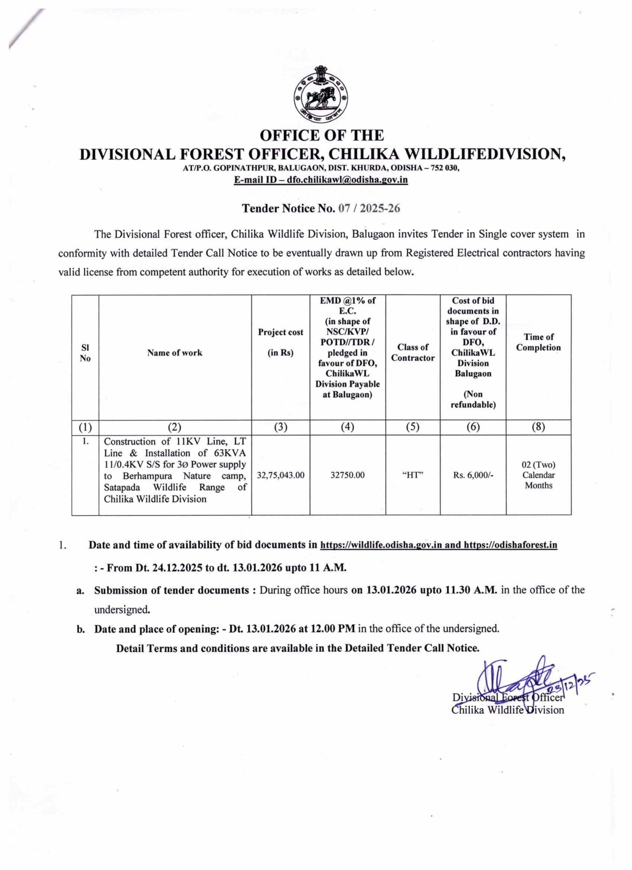

OFFICE OF THE
DIVISIONAL FOREST OFFICER, CHILIKA WILDLIFEDIVISION,
AT/P.O. GOPINATHPUR, BALUGAON, DIST. KHURDA, ODISHA – 752 030,
E-mail ID – dfo.chilikawl@odisha.gov.in

Tender Notice No. 07 /1WL- 706/2025,
Dated 23rd December 2025

Notice Inviting Tender
For

PROVIDING 3Ø POWER SUPPLY OF LOAD 45KW/49KVA BY INSTALLING 63 KVA,11/0.4 KV (HANDOVER TO TPSODL) S/S TO THE BERHAMPURA NATURE CAMPSITE AT-MAHISA BERHAMPUR VILLAGE UNDER MALUD ELECTRICAL SECTION.

Project Cost :Rs.32,75,043 /-
EMD :Rs.32,750 /-
Completion Period :02 months (Two months)
“Certified that, this tender document contains 31pages only”.

Sd/-
Divisional Forest Officer
Chilika Wildlife Division

SL NO. | PARTICULARS | DATE & TIME / DETAILS | LOCATION / DETAILS
1 | RFP No. & Date | Tender Notice No. 07 / 1(WL)-706/2025, Dated 23rd December 2025
2 | Commencement of Download of  RFP Document | 24.12.2025 ONWARDS | www.odishaforest.in and www.wildlife.odisha.gov.in
3 | Due date for submission of pre-bid queries through email and in standard format on Ms Word | Within a Week of Publish of this Tender | Email-dfochilikawl@odisha.gov.in
4 | Date of Pre-bid conference | 03/01/2026  (12:00 PM) | Office of the Divisional Forest Officer, Chilika WL Division, AT/P.O.-Gopinathpur, Balugaon, District-Khordha, Pin-752030
5 | Release of Corrigendum at website | 03/01/2026  (By 6:00PM) | www.odishaforest.in and www.wildlife.odisha.gov.in
6 | Date of Bid Submission  (By Messenger / Courier / Post) | 13/01/2026  (Up to 11.30AM) | Office of the Divisional Forest Officer, Chilika WL Division, AT/P.O.-Gopinathpur, Balugaon, District-Khordha, Pin-752030
7 | Date of opening | 13/01/2026  (12.00 PM) | Office of the Divisional Forest Officer, Chilika WL Division, AT/P.O.-Gopinathpur, Balugaon, District-Khordha, Pin-752030
8 | Contact Person for Queries | Office of the Divisional Forest Officer, Chilika WL Division, AT/P.O.-Gopinathpur, Balugaon, District-Khordha, Pin-752030
9 | Address of Bid Submission. | Office of the Divisional Forest Officer, Chilika WL Division, AT/P.O.-Gopinathpur, Balugaon, District-Khordha, Pin-752030
10 | RFP Document Cost  (Non-refundable) | Rs.6000/- (Rupees Six thousand only) |  | By Demand Draft issued by a nationalized or scheduled bank in favour of “Divisional Forest Officer, Chilika Wildlife Division” payable at Balugaon
11 | EMD  (Refundable, but non-interest bearing) | Rs.32,750/-  (Rupees Thirty TwoThousand Seven Hundred Fifty only) |  | (In shape of NSC/KVP/POTD/DD / TDR pledged in favour of DFO, ChilikaWL Division Payable at Balugaon)
12 | Bid validity period | 1 years from the last date (deadline) from the last date of submission of bids.
13 | Latest Tender document and addendum/corrigendum, if any, will be published at the websiteswww.odishaforest.in and www.wildlife.odisha.gov.in
15 | Disclaimer: Notwithstanding anything else contained to the contrary in this tender document, DFO Chilika Wildlife reserves the right to cancel / withdraw / modify fully or partially the “Invitation of Bids” or to reject one or more of the bids without assigning any reason and shall bear no liability whatsoever consequent upon such a decision.

Section – I: Invitation for Bids
  - Objective
The Divisional Forest Officer, Chilika Wildlife Division invites Item Rate Tender from Valid license holder (HT) contractor of repute from eligible contractors empanelled under any central Govt/State Govt. organization, PSU etc. having successfully completed works of similar nature as per eligibility criteria for the following work:-

“PROVIDING 3Ø POWER SUPPLY OF LOAD 45KW/49KVA BY INSTALLING 63 KVA,11/0.4 KV (HANDOVER TO TPSODL) S/S TO THE BERHAMPURA NATURE CAMP SITE AT-MAHISA BERHAMPUR VILLAGE UNDER MALUD ELECTRICAL SECTION.”
1.2 About the bid documents
The tender document comprises of the following:
Sections | Chapters
Section – I | Invitation for Bids
Section – II | Eligibility & Evaluation Criteria
Section – III | Scope of Work
Section – IV | Instruction to Bidders
Section – V | General Terms & Conditions of the Contract
Section – VI | Technical Specifications of Items(BOM)
Section – VII | Annexure(s) of Formats
A. The tender will have single bid system.
B. The tender document including addendum/corrigendum, if any, will be available only at websites –www.odishaforest.in , www.wildlife.odisha.gov.in
C. Bidders are requested to download the tender document from website and the tender document cost must be submitted along with their bid documents.
D. The tender document, after duly filled in, should be submitted in Office of the Divisional Forest Officer, Chilika WL Division, At/P.O.-Gopinathpur,Balugaon District-Khordha, Pin-752030 on or before the due date and time.
E. Cost of the Tender Document and EMD must be submitted along with the Bid Documents Only.
F. Bids received without or with inadequate Tender Document Cost and EMD shall be rejected.
G. Normally inclusion of missing documents will not be entertained after submission of the bid.
H. Bids shall be opened by the respective committeesdesignated for the same in the presence of bidders who may choose to attend the Bid Opening Event.

Section – II: Eligibility Criteria
The Bidder should have the following eligibility Criteria to participate in this Tender.
2.1General and Technical Eligibility Criteria (Necessary support documents are to be enclosed):
A. The Bidder should not bid under any Consortium. No Consortium bid shall be allowed for this Tender.
B. The bidder should be Valid license holder (HT) contractor of repute empanelled under any central Govt/State Govt. organization, PSU etc. having successfully completed works of similar nature with minimum 3 years of experience.
C. The bidder must have been registered with GST and must furnish the GST registration certificate, PAN and copy of up to date IT returnalong with the technical bid.
D. Average Annual turnover of the bidder for works under similar segment for last 3 (Three) financial years ending on 31 March, 2025, should not be less than Rs. 40.00 Lakhs (Rupees Fourty Lakh of Indian Rupees). Copies of Filed Audited Balance sheets, IT Returnsare to be submitted to corroborate this.
E. The bidder should not be under a declaration of ineligibility for corrupt and fraudulent practices issued by Government of India or any State Governments in the country of India. (Self declaration to be furnished)
F. The bidder must not have any history of defaulting in execution of work orders issued by Government of India or any State Government in the country of India. A self-declaration certificate to this effect should be enclosed.
G. The bidder hasn’t been blacklisted by any Central/State Government institution and there has been no pending litigation with any government department on account of similar services. A self-declaration certificate to this effect should be enclosed.
H. No Criminal Proceedings in any Court of Law should pending against the bidding Firm Or its Promotors Or its Directors in the Company Board who is directly involved in this tender. (A self-declaration certificate to this effect should be enclosed)
I. Materials must be procured from TPSODL enlisted vendors. Materials must be inspected at TPSODL site.
J. Warranty period of two years must be given in the work.
K.-All payments to TPSODL (statutory payments) will be done by the contractor and no hidden cost should be mentioned later.
Note: E-H can be submitted under one Self Declaration Certificate.

2.2 Technical Eligibility Criteria: (Necessary support documents are to be enclosed)

- The EMD amount is to be furnished as prescribed in favour of the Divisional Forest Officer, Chilika Wildlife Division, Balugaon
- Certificates of Work Experience & Completion Certificate of Similar Work from Clients not below the Rank of Exécutive Engineer or equivalent.
- Certificate of Registration for GST
- Copy of PAN Card.
- Copies of Balance Sheets.
- Copies of Contractor’s valid Electrical License (HT)
- Copies of ESI Registration.
- Copies of EPF Registration.
- The Bidder should have their Registered Office / Branch in Odisha.
- Declarations to be given by the Tenderer.
- No Relation Certificate.

Necessary supporting documents on fulfilment of eligibility criteria should be attached for authenticationalong with a signed copy of the tender document including addendum/ corrigendum, if any, to indicate acceptance of all terms and conditions set forth in the tender.Original copies of the submitted documents should be produced for verification when required. Organizations failing to provide complete information on any of the requirements are liable to be rejected.

Section – III: Scope of Work

The broad scope of work is defined as under:
A. The bidder/supplier shall provide solution for the requirement and include any missing item(s) notwithstanding the detailed Bill of Material (BOM) in the specifications given in the tender document for the successful end to end implementation.
B. The successful bidder/supplier shall not cause any damage to Government buildings/other premises/property during supply/ transportation. If any damage occurs, the successful bidder/supplier will perform restoration.
C. The successful bidder/supplier shall provide warranty for all the components and subcomponents for the warranty period and make it available from the OEM.
D. Detailed training for operation and management of equipment/infrastructure will be provided to the selected representative Staff. No separate cost will be added for this purpose.
E. The work is to be completed within a period of 2months from the date of issue of the work order.
F. The time frame for work execution is most important and should be strictly adhered to. All terms and conditions specified in the letter No. 1615 dated 01.11.2025 of the Executive Engineer(Electrical), Ganjam North Electrical Division of TPSODL while according approval of the work and estimate must be followed by the successful bidder as per Govt. guidelines. The copy of the approval is given below.
G. The materials to be installed and costs (Bill of quantities) are mentioned in the approval accorded by the TPSODL. These must be thoroughly read by the bidders and they must quote in the financial bid accordingly.

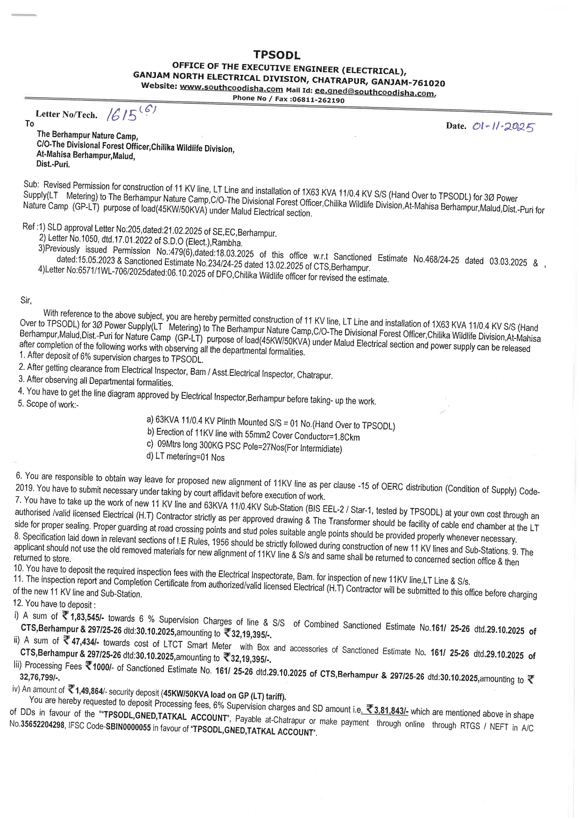
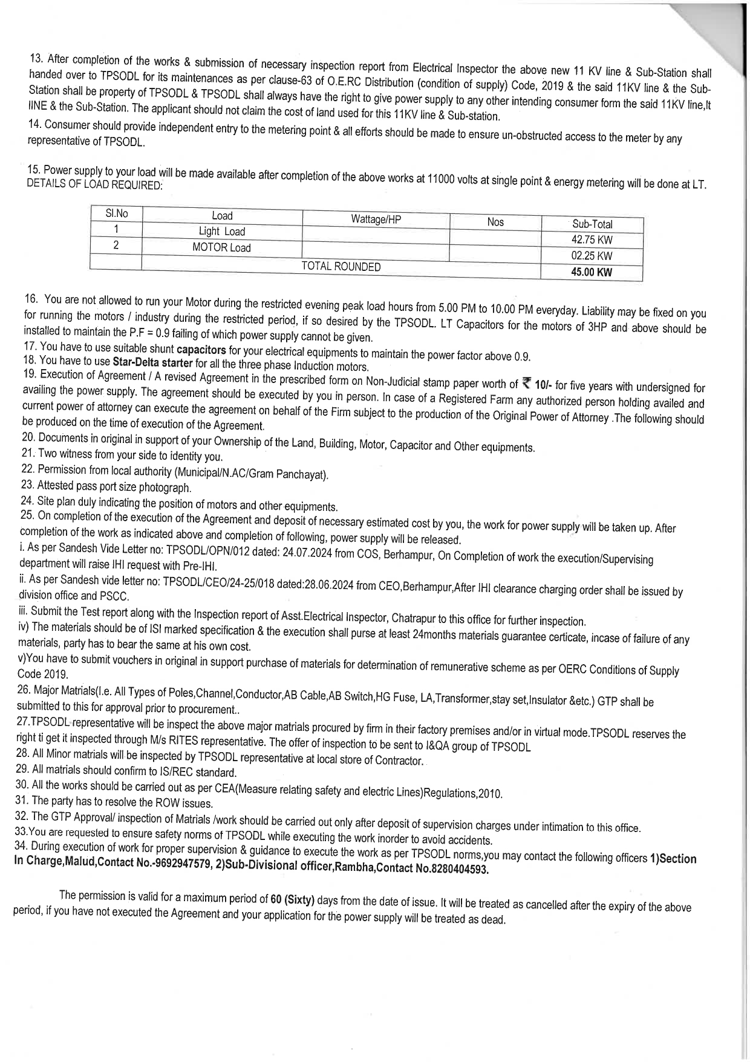

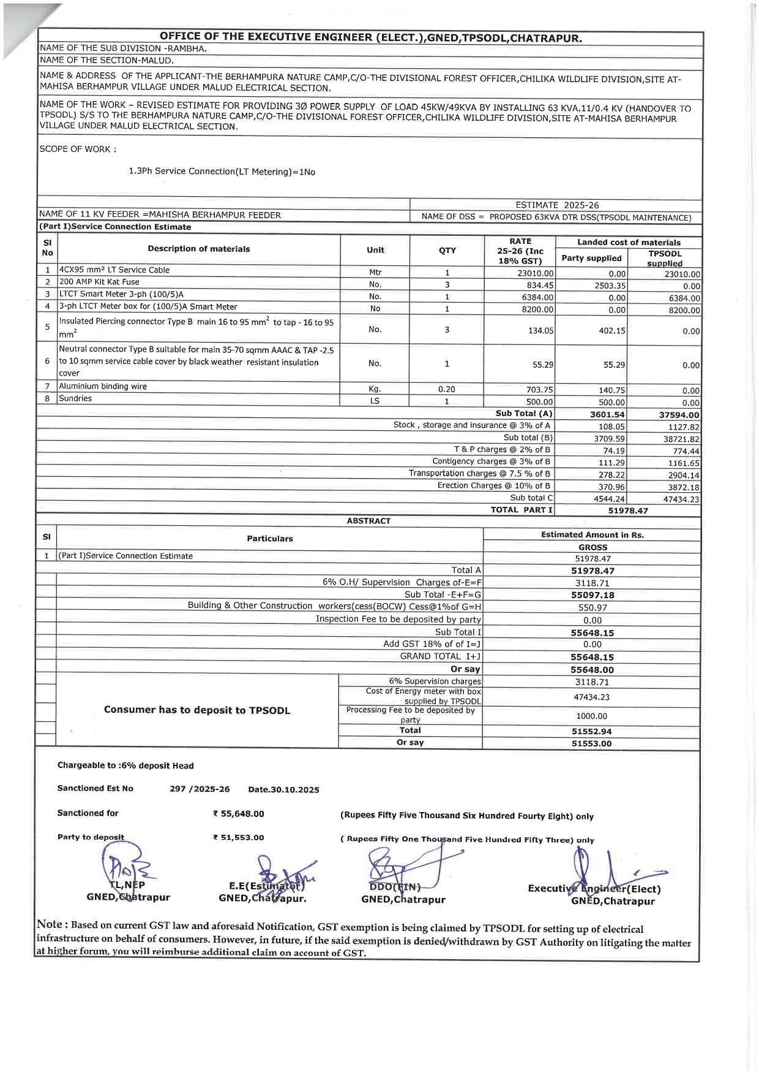
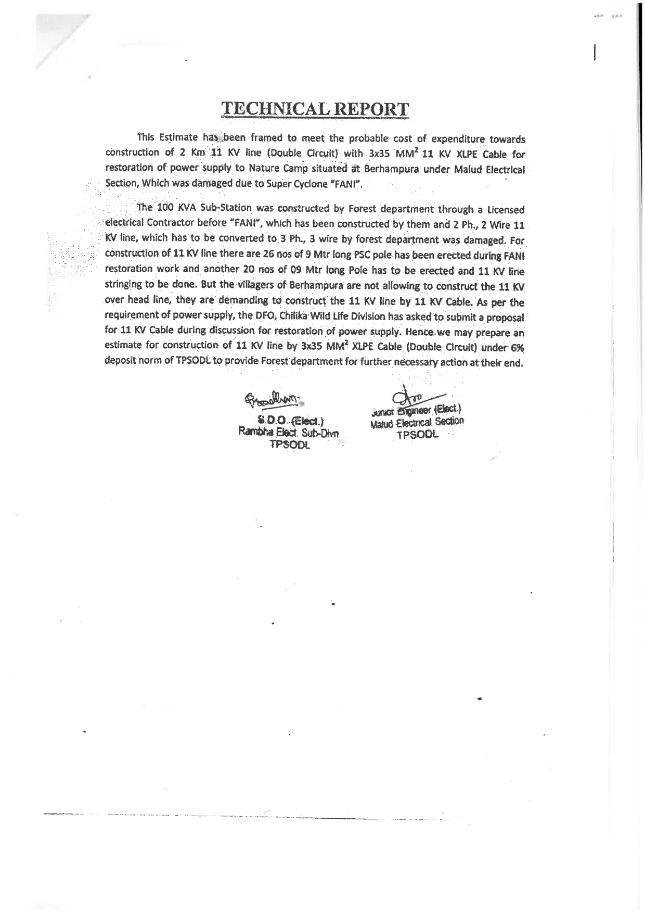
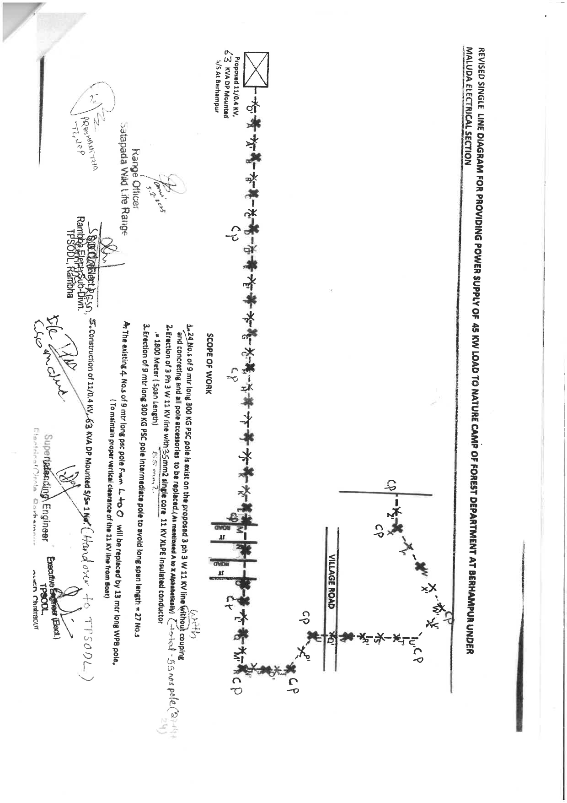
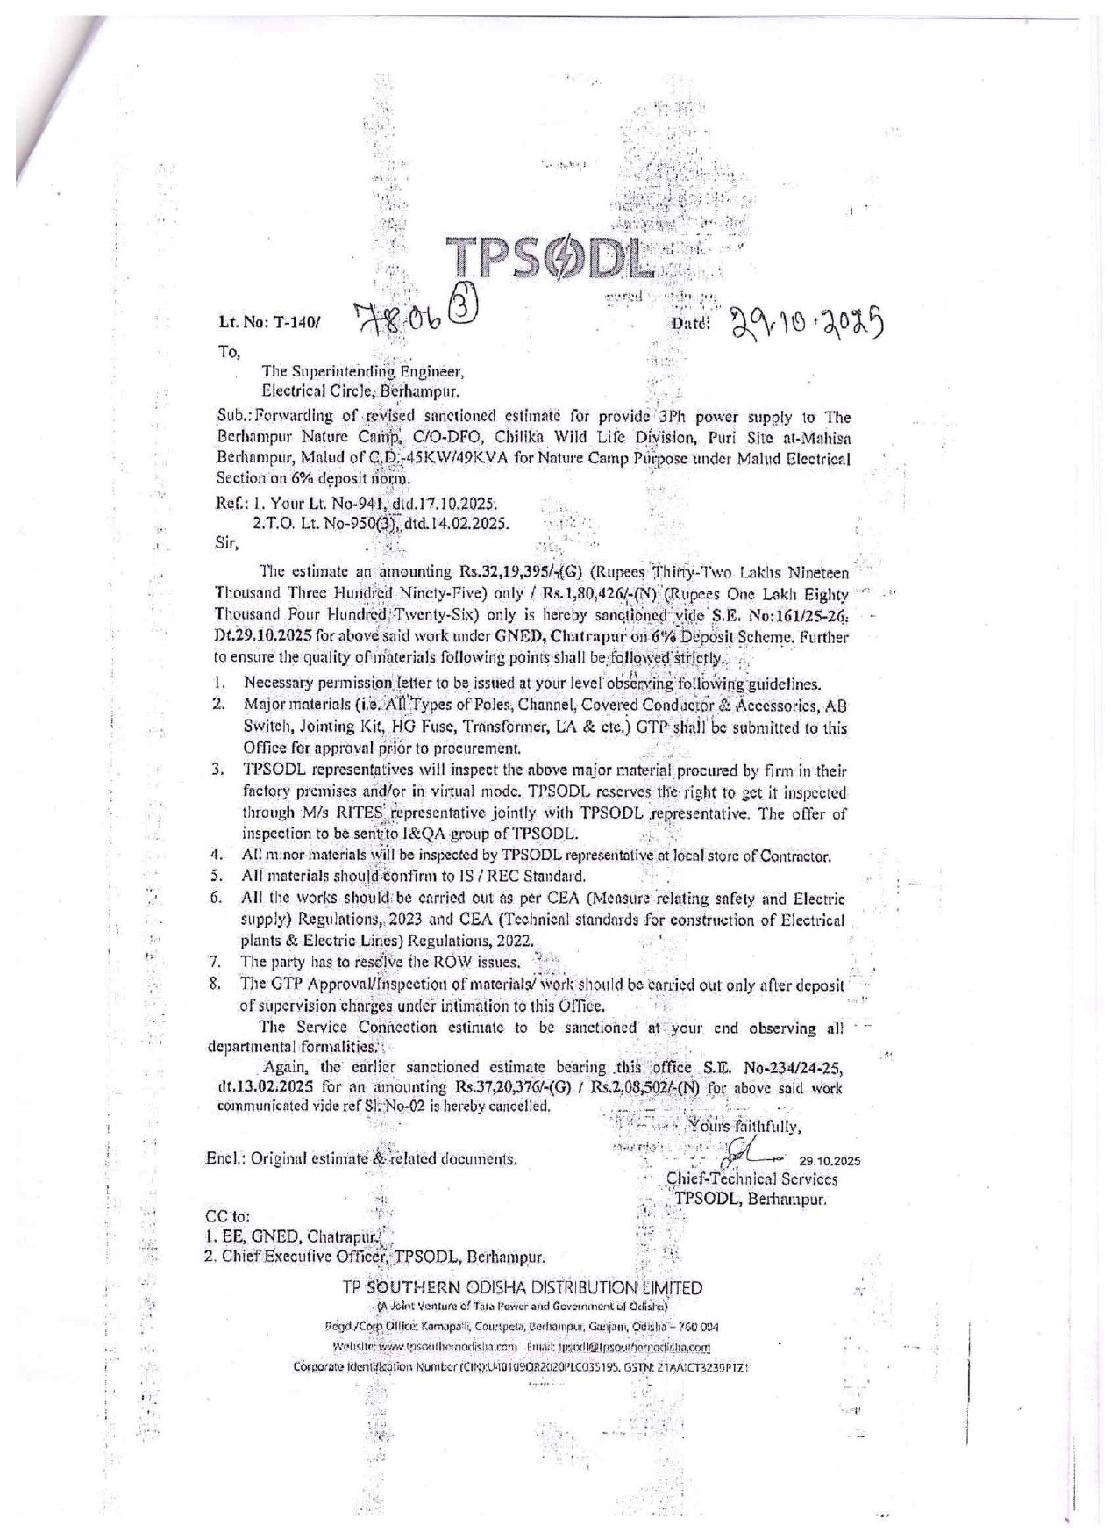
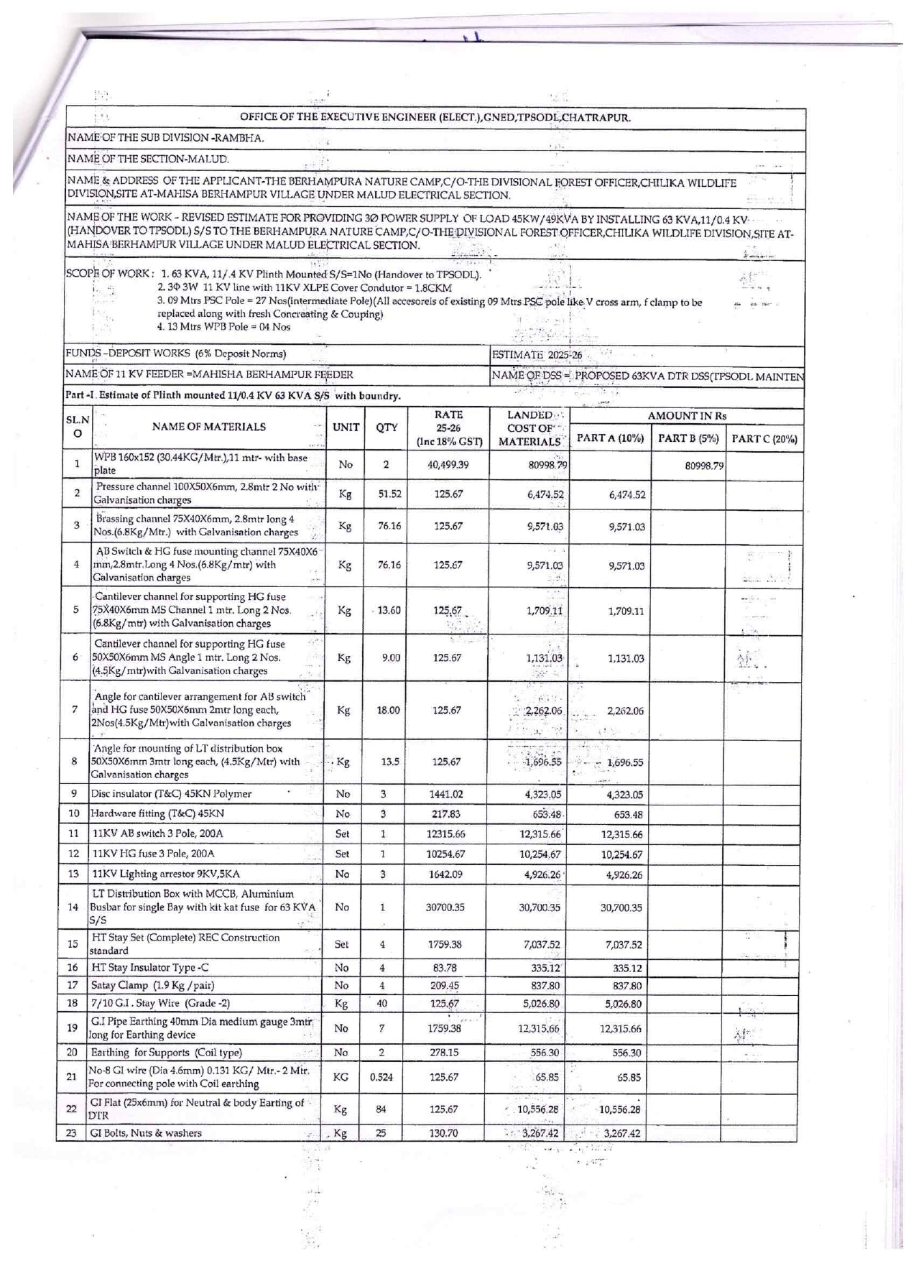
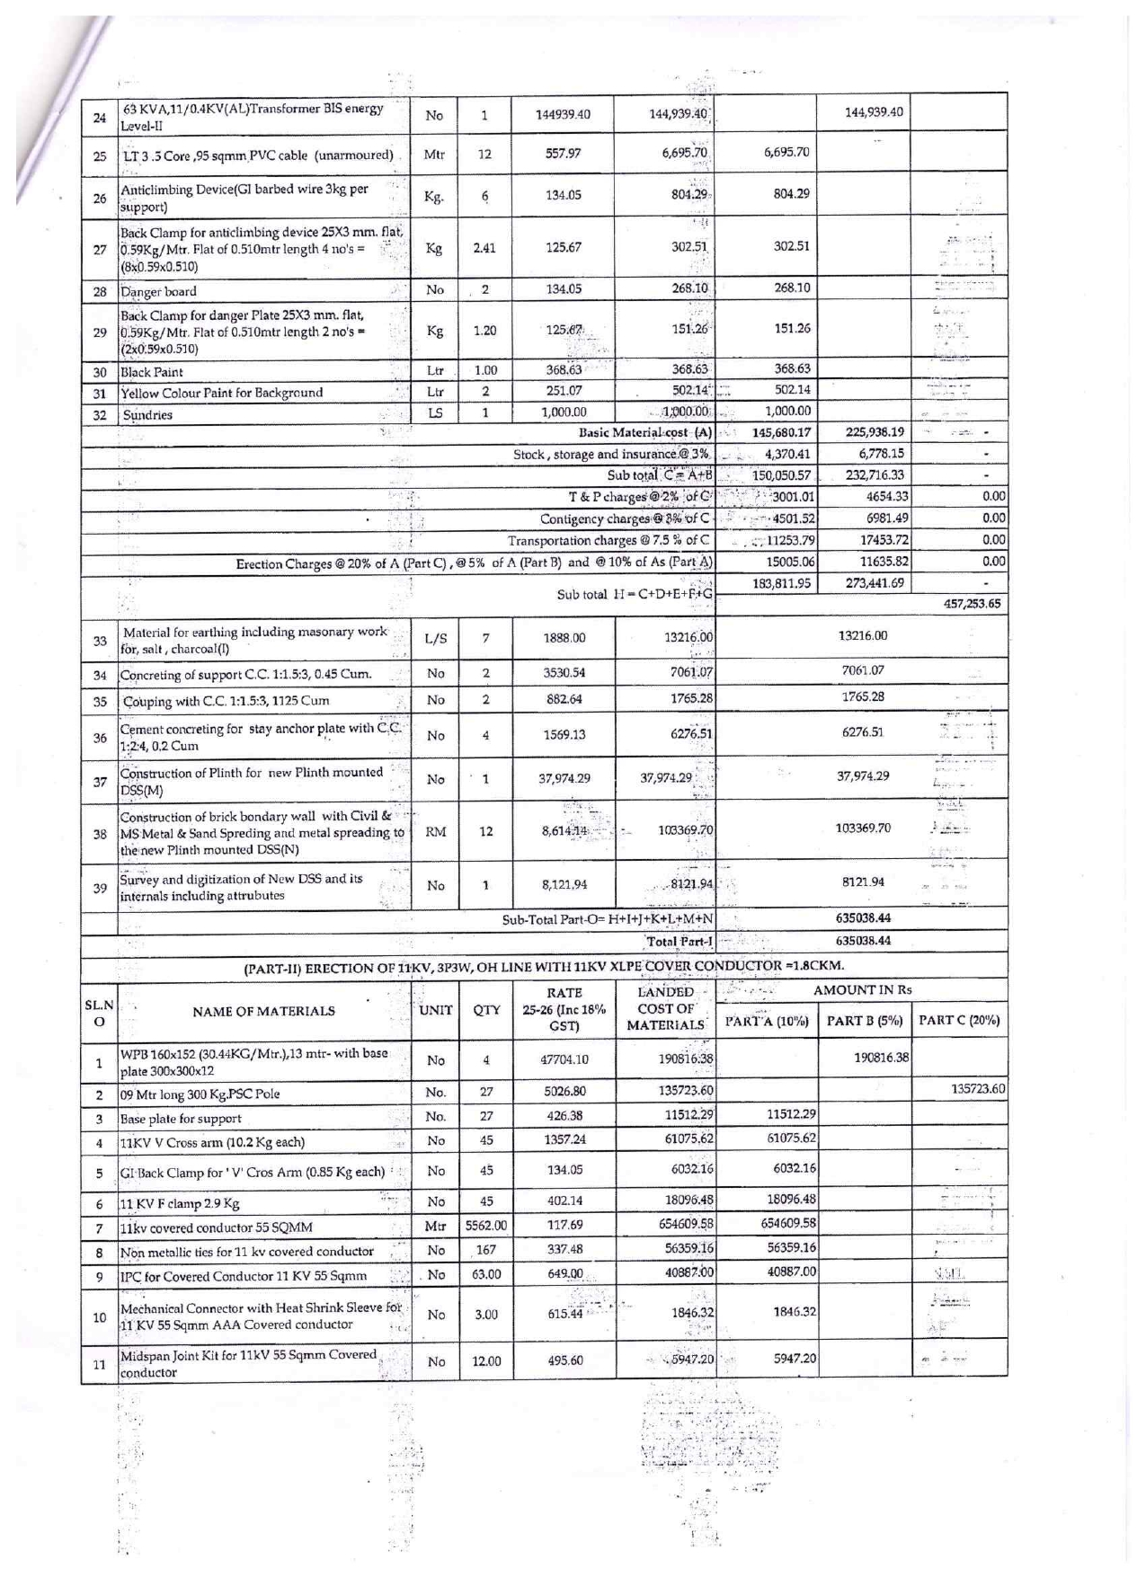
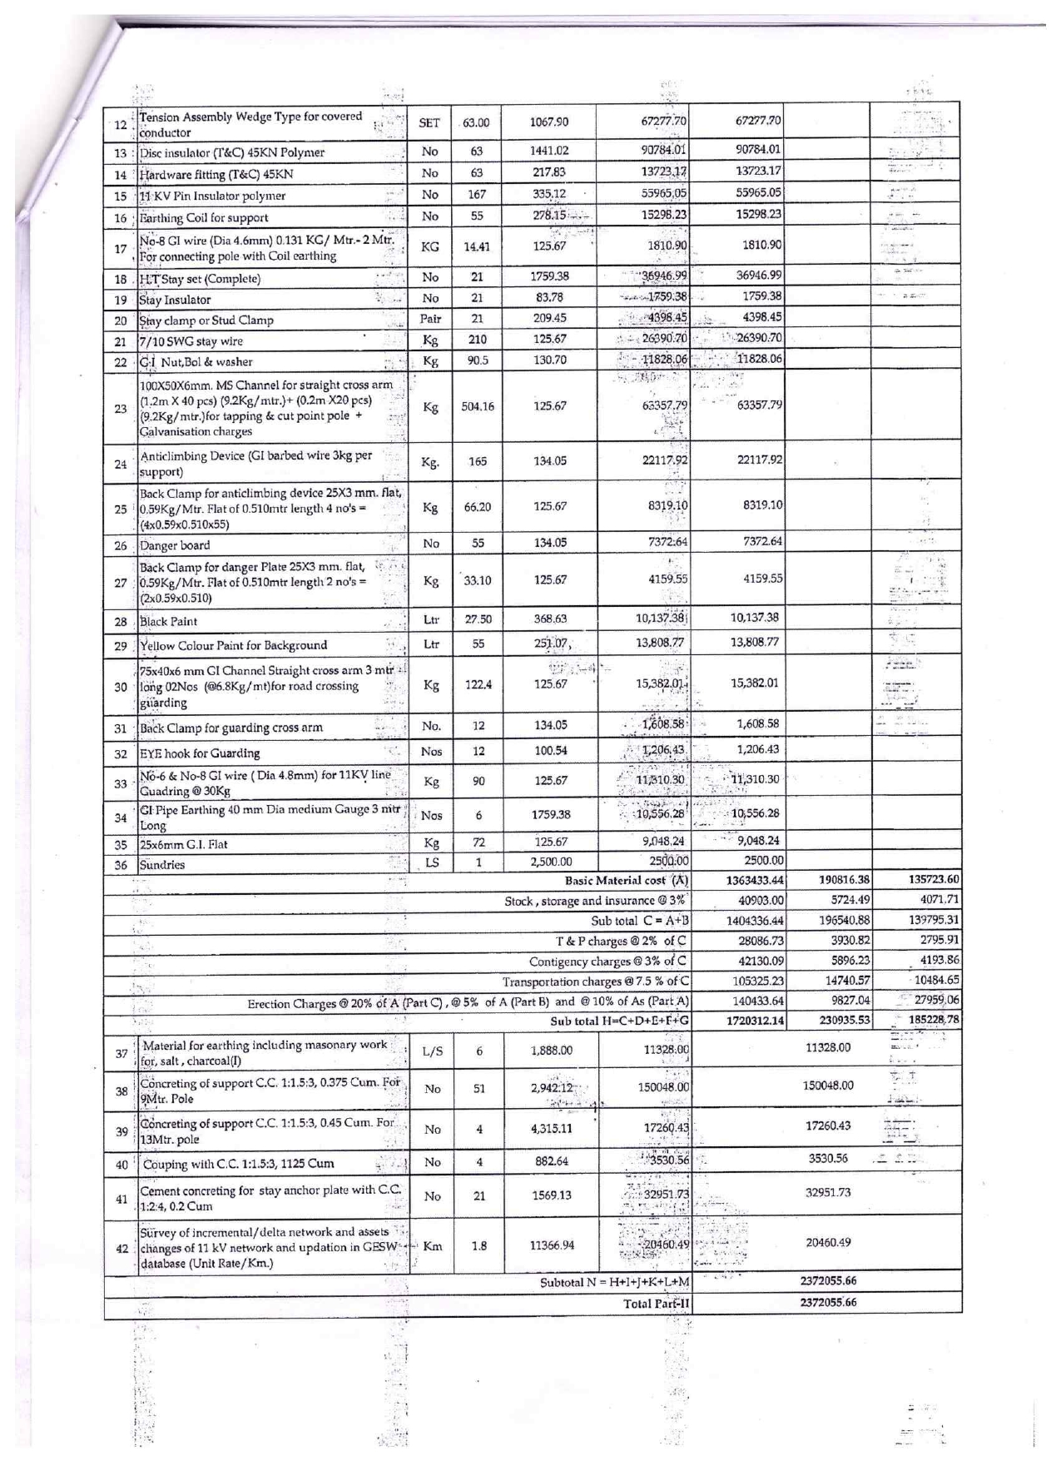
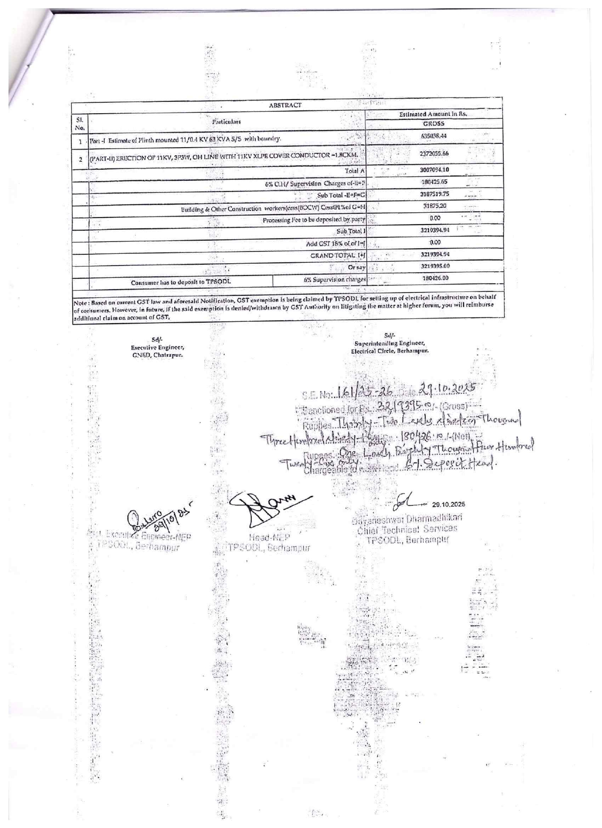

Section – IV: Instruction to Bidders

  - The intendingbidder must read the terms and conditions of Tender document carefully. He shouldsubmithisbid if heconsidershimselfeligible and heis in possession of all the certificates / documents required.
  - The bid document consisting of NIT, plans, specifications, the schedule of quantities of various types of items to beexecuted and the set of terms and conditions of the contractare to becompliedwithothernecessary documents.
  - Copies of eligibility documents and EMD as specified in the notice inviting tender shallbewithin the period of tender.
  - Bidders must ensure to quote rate of in % (Percentage) basis and the quoted rate shouldbeincluding all official deposit.
  - Intending bidders are advised to inspect and examine the site and itssurroundings and satisfythemselvesbeforesubmittingtheirbids, the means of access to the site and in generalshallthemselvesobtain all necessary information as to risks, contingencies and othercircumstanceswhichmay influence or affect theirbid. A biddershallbedeemed to have full knowledge of the site whetherheinspectsit or not and no extra charge consequent on anymisunderstanding or otherwiseshallbeallowed. The biddershallberesponsible for arranging and maintaining at his owncost, all materials, tools& plants, water, electricityaccess, facilities for workers and all other services required for executing the workunlessotherwisespecificallyprovided for in the contract documents. Submission of a bid by a bidderimpliesthathe has readthis notice and all othercontract documents and has made himselfaware of the scope and specifications of the work to bedone and of conditions.
  - Financial bidsshallbeopened for whom EMD and other documents are found in order and who are found to beeligible to bid for work. On opening date, Afteropening of bidshewillreceive the competitorbidsheets.
  - If the contractorisfoundineligibleafteropening of bids, hisbidshallbecomeinvalid.
  - If anydiscrepancyisnoticedbetween the eligibility documents, bid and hard copies as submittedphysically by the bidder, the bidshallbecomeinvalid.
  - The bidderwillbecompletelyresponsible for successfulcompletion of the work as per requirement.
  - Delivery and commissioning of the items for the aboveworkshallbecompletedwithin 2 monthsfrom the date of issue of Supply/ purchase /workorderpositivelywithout fail. Time overrun for installation and commissioning may lead to imposition of fine by the Purchaser @ 0.5 % of Bid Value per Week of Time Overrun and the orderis liable to becancelled.
  - The bid documents are to be put in a single envelope addressed to “Divisional Forest Officer, Chilika WL Division, AT/P.O.-Balugaon, District-Khordha, Pin-752030”.

  - The envelope containing the bid must show the name of the tenderer, address and should be superscribed as 3Ø POWER SUPPLY OF LOAD 45KW/49KVA BY INSTALLING 63 KVA,11/0.4 KV (HANDOVER TO TPSODL) S/S TO THE BERHAMPURA NATURE CAMP SITE AT-MAHISA BERHAMPUR VILLAGE UNDER MALUD ELECTRICAL SECTION.on the top of the envelope.

  - A non-refundabledemand draft of Rs. 6000/- (Rupees Six thousandOnly) as Tender Document Cost and an EMD of Rs. 32,750/- (Rupeesthirty two thousand seven hundred fiftyonly) in the modes mentioned in the tender document, must beenclosedalongwith the General Bid documents which must be payable at Balugaon.
  - General bid document not accompanying the requisite Tender document fee and EMD shallbeconsidered as non-compliant, summarily rejected and will not beconsidered for furtherevaluation. Exemptions, if any, must beclearlyspelt out by the biddingfirm and the purchaser has the sole discretion of grantingsuch exemptions as per provisions/ guidelines of the State Govt/ Central Govt.
  - Pre BidQueries:
- Bidders are not bound to attend Pre Bid Query Meeting in order to participate in the bidding, it is purely optional.
- Purchaser is not bound to answer or respond or incorporate the requests made under all Pre Bid Queries by the Bidders.
- Pre Bid Queries are to be submitted by the bidders before designated date by e-Mail only and these queries should be specific with respect to this tender document and under the following tabular format only in an MS Word File Attachment.
# | RFP Document Reference by Sections & Page Numbers | Exact and Contents of RFP that requires Clarifications in a Pointed Manner.
d.Pre-Bid queries in the form of advisory notes shall not be entertained.
e. The Bidder or Bidder’s designated representative (with authorization and credentials from the vendor citing his position and domain expertise) are invited to attend the Pre Bid Meeting at their own cost, which will take place on the date and time stipulated in the Schedule of Events.
f. Keeping with the space constraint of the meeting space, maximum one person per bidder are allowed in the Pre Bid Meeting Sessions.
g. The Bidders / their representatives are requested to carry a hard copy of the tender document with them for their ready and handy reference.
h. The purpose of the meeting will be to clarify pertinent issues with respect to the relevant and pertinent Pre Bid queries mailed by the bidders and other pertinent queries by the bidders with respect to the clause and section of the tender document in a Serial and Sequential Order Only, i.e. from start to the end clause of the document with economics of time in the deliberations.
i. Any modification / corrigenda / addenda of the tender document if at all necessaryas a result of the Pre Bid Meeting and necessity of the purchaser only shall be published in the websites www.odishaforest.in and www.wildlife.odisha.gov.in. Bidders are requested to frequently refer the websites for updated information as updates will not be communicated to bidders individually by the purchaser.

j. Any such corrigendum/addendum shall be deemed to be incorporated into this RFP and shall be binding on all bidders.
4.16. The sealed tenders will be opened as per the indicated schedule in presence of the tenderers or their authorized representatives as may desire to be present. Authorized representatives will be required to produce their authorization letter before opening of the tender, failing which they will not be allowed to be present.
4.17. Technically qualified bidders will only be informed for their financial bid opening within stipulated time as approved by the PCCF(WL)& CWLW, Odisha and this will be communicated to the firm through e-mail. Any clarification/alteration in specification found suitable by the technical committee will be informed to the successful bidders for commercial inclusion.
4.18. Tenders shall be fully in accordance with the requirements of the general terms and conditions and the technical specifications attached hereto. Appropriate formats furnished with this specification shall be used in quoting tender prices. Incomplete, illegible, unsealed and without signature tenders will be rejected. Telegraphic tenders will not be accepted.
4.19. All offers should be made in English and clearly type written. Offers if submitted in any other language must be accompanied by its English Translation in which case, for purpose of interpretation of the tender etc, the English translations shall prevail.
4.20. The bidders should furnish the following information and documents with the General, Technical and Financial Bids.
4.21. Tender should be submitted in the O/o the DFO, Chilika WL Division, Balugaon. No tender is to be handed over to office staffs unless otherwise specified officially.
4.22. In case due date happens to be holiday the tender will be accepted and opened on the next working day. No separate intimation will be sent to bidders in this regard.
4.23. Bidders shall bear all costs associated with the preparation and submission of its bid, and the purchaser shall not be responsible or liable for those costs, regardless of the conduct or outcome of the bidding process.
4.24. Alternative bids / Bids on Alternate Format than Prescribed in this Tender Document shall not be considered and Conditional Tenders will be summarily rejected with forfeiture of the EMD. Bids are to be submitted in the Prescribed Formats Only. Submission of alternative bids or conditional bids shall be treated as attempt to vitiate the bidding process by the bidder.
4.25. The supplier shall pay and bear all other liabilities, taxes and duties not specifically agreed by the Purchaser in the contract.
4.26. The leaflets/catalogue and standard technical literature etc. of the technical features of the offered equipment’s must be submitted for proper evaluation.
4.27. Warranty/Guarantee: Minimum one (01) year of On-Site Comprehensive Warranty is to be provided on the products (or OEM available warranty) so quoted from date of satisfactory delivery and commissioning.
4.28. Tenders shall be fully in accordance with the requirements of the general terms and conditions and the technical specifications attached hereto. Appropriate formats furnished with this specification shall be used in quoting tender prices. Incomplete, illegible, unsealed and without signature tenders will be rejected. Telegraphic tenders will not be accepted.
4.29. PRICE BID MUST BE SUBMITTED IN ENCLOSED PRICE BID FORMAT ONLY.

4.30. Quantity: The quantity shown in the tender will not be deviated under normal conditions.
4.31. The rates quoted by the bidder against items contained in bill of quantity of the Tender document, shall be inclusive of all Taxes. The various items of testing, commissioning and maintenance shall be inclusive of all costs such as GST applicable in Odisha.
4.32. The price and conditions of the offer should be valid for at least a period of 1 year from the date of tender opening. Tender with validity of less than 60 days may be rejected.

4.33. Bid Security:

a. The Tender must be accompanied by a sum of Rs.32,750/- (Rupees Thirty Two Thousand Seven Hundred Fifty Only) as EMD in the form of Demand Draft/ Bank Guarantee on any of the nationalized banks in favour of “Divisional Forest Officer, Chilika Wildlife Division” payable at Balugaon, failing which the Tender shall be considered as noncompliant and summarily rejected. The EMD is liable to be forfeited, if the bidder withdraws or amends impairs or derogates from the tender in any respect within the period of validity of his offer. In case of a successful bidder the bid security (EMD) shall be forfeited if the bidder fails to accept the Work/Purchase Order or fails to furnish performance security after accepting the Work/Purchase Order within seven (7) working days of issue of Work/Purchase Order.
b. The EMD of all unsuccessful bidders will be returned by DFO Chilika Wildlife Division without any interest whatsoever within thirty (30) days of finalization of the tender and the EMD for successful bidder/bidders would be returned without any interest whatsoever, only after receipt of performance security / bank guarantee ; as called for in the contract.

c. The bidder will sign a contract with the purchaser within a week of issue of supply / work order and the Bidder shall submit an irrevocable Performance Bank Guarantee before signing the contract. The Performance Bank Guarantee is to be issued by a Nationalized/Scheduled Bank Payable at Balugaon and it will be 3 % of the Bid Value for the Contract Period. This will be invoked by the purchaser in case of default of T & C of contract by the bidder.
4.34. Bidders shall carefully examine the tender documents and the technical specification and fully inform themselves as to all the conditions and matters, which may in any way, affect the work or the cost thereof. Should a bidder find discrepancies in or omissions from the specification or other documents, or should there be any doubt as to their meaning, they should at once notify the purchaser and obtain clarification in writing. This however does not entitle the bidder to ask for time beyond the due date fixed for receipt of tenders.
4.35. Verbal clarification and/or information given by the purchaser or its employees or representatives shall not be binding on the purchaser.
4.36. Submitted tender forms with overwritten or erased or illegible rate or rates not shown in figures and words in English will be liable for rejection. In case of discrepancy between words and figures noted against the item of the tender and between unit rates and the total amount, the decision of the competent authority accepting the tender will be final and binding on the bidders. Corrections in the tender, if unavoidable, should be made by rewriting with date and initial of the tenderer after scoring out of the wrong entries. Clerical and arithmetical mistakes may result in rejection of the tender.
4.37. While tenders are under consideration, bidders and their representatives or other interested parties, are advised to refrain from contacting by any means, and Purchaser's personnel or representatives on matters relating to the tenders under study. The purchaser if necessary will obtain clarification on tenders by requesting such information from any or all the bidders either in writing or through personal contact as may be necessary. The bidder will not be permitted to change the substance of his offer after the tenders have been opened. This includes any post tender price revision/major modifications. In the event of non-compliance with this provision, the tender is liable to be disqualified.
4.38. The rate should be quoted in figures as well as in words, if there is variation between the rates quoted in figures and in words, the rates quoted in ‘Words’ shall be taken as correct.
4.39. Evaluation criteria:
a. The technical eligibility criteria will be checked thoroughly as per the conditions given in the tender.
b. The selection will be done on the basis of lowest cost criteria(L1). In case of a tie, transparent lottery will be donein the presence of the bidders who choose to attend.
c. The evaluation committee may invite the eligible bidders to make a Demonstration to them at a date, time and location notified. The purpose of such Demonstration would be to allow the bidders to present their quoted items to the committee if required.
d. The financial bid will be as per the format attached.
e. Award of the contract shall be made to the bidder with the lowest (L1) commercial value by taking in to account all the items. The Base Price of the Items will be considered in Evaluation of Financial Bid that excludes all taxes

f. Taxes will borne by the Purchaser at the prevailing Tax Rate as it is a transfer payment between Govt-Govt. However Tax is to be indicated in the Financial Bid for the Purpose of Information Only.
g. Purchaser reserves the right to negotiate specifications, prices during evaluation if found necessary.

4.40. Bidders must sign and stamp each page of their tender without which the tender will be considered incomplete.

Section – V: General Terms & Conditions

1. PURCHASER

Divisional Forest Officer, Chilika Wildlife Division,Balugaon
2. RELEASE OF EQUIPMENT

The bidders shall be responsible for releasing the equipment’s/items from the carriers/ transporters. The equipment’s shall be delivered and installed in the designated location as mentioned in the tender document.

3. PERFORMANCE BANK GUARANTEE (PERFORMANCE SECURITY)

For items mentioned in Table-1 Section -III, after successful installation at site, the bidder shall furnish an irrevocable Performance Bank Guarantee (PBG) for 3% (three percent) of the contract price prior to the release of any payment. The BG should cover due fulfilment by the bidder of all the terms and conditions of the contract inclusive of guarantee to the purchaser the delivery, installation / commissioning of equipment, the restitution of advances to the supplier in advance of delivery in case of non-delivery and the contractor's full compliance with the warranty and guarantee provisions here in the form to be prescribed. This bank guarantee shall remain valid till the end of support period/warranty period.

4. PRICE

The prices quoted should be in Rupees for delivery F.O.R. destination. Any price other than F.O.R. destination price will not be considered. The F.O.R. destination price should be inclusive of Entry Tax. GST amount should be mentioned clearly and separately.
5. TERMS OF PAYMENTS

A. 100% of the contract price (i.e cost of the Items actually supplied) shall be paid within 7 days days of successful delivery, Installation, Commission and Testing of all the Equipments at site with certification thereof by designated departmental authority and OEMs of supplied items, submission of Performance Security and bill by the Bidder. This will be spelt out in the agreement to be executed in details. Changes if any will be spelt out in the agreement.

6. BILLING

The supplier shall specify the Branch / Location from which they will raise the bill and in whose favour payment will be released.

7. DELIVERY AND INSTALLATION
The supply and delivery will be as per location mentioned in the tender document.
8. PENALTY FOR DELAY IN COMPLETION OF CONTRACT

The delivery/ installation/commissioning period quoted in the tenders should be guaranteed under a penalty @ 0.5% on total value of the equipment per week or amount thereof of delay subject to

maximum 5% of the contract/purchase order value. The purchaser reserves the right to cancel the order if it is not executed within the prescribed completion time and forfeit the entire EMD amount. Delay in supply / installation /commissioning in the part of the supplier for equipment shall be treated as delay in the delivery/ installation of the goods. The purchaser reserves the right to cancel the order in full or in part. In the event of such cancellation, the purchaser shall have the right to collect penalty from the performance guarantee. However, for valid reasons (like any unavoidable situation at the client site) duly notified in advance and considered by the purchaser, revised delivery schedule may be accepted at the sole discretion of the purchaser.

9. FORCE MAJEURE CONDITION

If the execution of the contract/supply order is delayed beyond the period stipulated in the supply order as result of outbreak of hostilities, declaration of an embargo or blockade of fire, flood, acts of God, then purchaser may allow such additional time by extending the time frame as considered to be justified by the circumstances of the case and its decision will be final. If additional time is granted by the purchaser, the supply order shall be read and understood as if it had contained from its inception the execution date as extended.

10. STANDARDS

Theequipmentsshall confirm to the National / Internationally Accepted standards as applicable. Necessary Documentation on compliance to standards are to be provided against each item as has to be certified by the concerned department.

11. COMPLETENESS OF EQUIPMENT

The equipment shall be complete in all respects andhas to be certified by the concerned department. Any components fitting, etc. which may for the equipment shall be deemed to have been included in the contract and shall be supplied by the supplier/bidder at no extra cost.

12. INTERCHANGEABILITY
All similar materials shall be identical and interchangeable with one another in order to minimize the number of spare parts.

13. SALES TAX AND INCOME TAX CLEARANCE

The attested copies of GST &Income Tax Clearance Certificate should be enclosed with the tender. Certificate validity must be available on the date of opening of General Bid.
14. INSURANCE OF EQUIPMENTS

The materials to be supplied should be insured by the vendor on behalf of the purchaser from his warehouse to the purchaser's site. The insurance coverage should cover the transport of materials by Rail/Road/ Waterway to the destination. The insurance policy shall remain valid for minimum period of 60 days after installation and commissioning of equipment at site. The materials/equipment found lost or damaged in transit or during installation and commissioning should be immediately replaced.

15. REPLACEMENT

If the material/ equipment or any portion thereof gets damaged or lost during the transit and installation, the vendor shall effect the replacement of such materials/ equipment within a reasonable time to avoid delay in commissioning the equipment. The boats/ equipment which are Defective on Arrival(DoA) must be replace immediately without any negotiation with the purchaser.

16. RIGHT TO REJECT/ACCEPT THE TENDER

The purchaser reserves the right either to reject or accept any or all tenders. The purchaser has exclusive right to alter the quantities of materials at the time of placing the final purchase order. The type and quantity of items indicated in the tender are provisional and may change as per the actual requirement. After placing the purchase order, the purchaser may order to defer the delivery of the material. It may be clearly understood by the bidders that the purchaser need not assign any reason for the above action.

17. INSPECTION

The purchaser or his authorized representatives/ representatives as designated by the purchaser may inspect during the delivery, installation and commissioning of the equipments/items at the client site and the vendor shall afford all facilities for such inspection at the site. The bills shall be submitted by the bidder after such inspection and will be paid only after due certification by the electricity department personnel..

18. WARRANTY

The equipment / stores covered by this specification should be under free guarantee for satisfactory operation for a period of 1 yearfrom the date of successful installation and commissioning

19. REJECTION

Before acceptance of the system if the equipment supplied by the vendor is found defective in materials or workmanship or otherwise not in conformity with the requirements of the contract, the purchaser shall have the right to either reject or to request in writing for rectification of the defects. Then the bidder shall with utmost diligence, at his own expense, make good the defects so specified or replace the defective equipment if the bidder fails to do so, the purchaser either.
A. May at its option replace or rectify such defective equipment and charge to the bidder the excess cost incurred by the purchaser plus 15% (Fifteen percent) extra.

OR
B. Terminate the contract for default. Further, in the event, the vendor is not able to rectify or replace the faulty equipment within reasonable time, the purchaser reserves the right to acquire the said equipment at a reduced price considered equitable under the circumstances, and under such conditions the decision of the purchaser shall be final.

20. PATENT RIGHTS ETC.

The bidder shall indemnify the purchaser against all claims, actions, suits and proceedings for the infringement or alleged infringement of any patent, design or copy write protected either in the country of origin or in India by use of any equipment supplied by the vendor claims if made on the purchaser, shall be notified to the vendor of the same and the vendor shall at his own expense either settled such dispute or conduct any litigation that may arise there from.

21. JURISDICTION OF HIGH COURT OF ODISHA

Suites, if any arising out of the contract shall be filed by either party in a court of Law to which the jurisdiction of the High Court of Odisha extends.

22. EXTRAS

The bidder shall when asked in writing by the purchaser, perform extra work and furnish extra materials, not covered by the specifications or included in the schedule, but forming and inseparable part of the work contracted for the terms of payment for such extra work or materials shall be mutually agreed upon in advance.

23. INSTALLATION SUPERVISION AND SERVICES

The bidder shall depute experienced Engineer/Technicians for installation, commissioning and testing of equipments supplied.

24. EXTENSION OF DELIVERY PERIOD AND TERMINATION OF CONTRACT
In no case extension of delivery time will be allowed and any extension will lead to termination of contract.
27. OBLIGATION TO CARRY OUT PURCHASER'S INSTRUCTION

The Vendor/Supplier shall also satisfy the purchaser or his inspector that adequate provision has been made to carry out his instructions fully and with prompt attitude.

28. TIME AND DATE OF COMPLETION OF CONTRACT

The time and date stipulated in the tender for the completion of the work shall be deemed to be of the essence of the contract. In case of delay the vendor shall in addition to other liabilities under the contract be liable for all cost of damage and/or hold up in the work due to his failure to complete the contract or portion thereof. The purchaser shall be entitled to withhold any payment until the whole work is completed and recover from the vendor cost damages and/or held up in the work as stated above. But if the delay is due to any cause such as strike, lockout fire, accident, riot that the purchaser may admit as reasonable ground for further time, the purchaser shall allow such additional time as he may consider to have been required by the circumstances of the case.

29. FINAL AUTHORITY

The final authority for payments will be the purchaser except otherwise specifically stated and if the bidder desires to appeal against any matter he shall appeal to “The Principal Conservator of Forests, Wildlife & Chief Wildlife Warden , Odisha” whose decision on such matters shall be final and conclusive.

Section – VII
ANNEXURES
FORM FOR DETAILED INFORMATION BY BIDDER

Name of Firm/Contractor/Supplier :

Complete Address and Telephone Number :

Name of Proprietor/Partner/Managing Director/Director :

Phone Number :

Mobile Number :

e-Mail ID :

Name and address of service centre :

Whether the firm is a registered Firm :
(Yes/No. Attach Copy of Certificate)

PAN Number. :
(enclose the attested copy of PAN Card)

GST Number :
(enclose the attested copy of VAT Certificate)

Whether the firm has deposited the Bank Draft/Pay Order/ :
of Earnest Money Deposit (EMD).
Whether the Firm/Agency as signed each and every page of :
Tender/NIT
EPF No. :
(Enclose the attested copy of EPF Registration Certificate)
ESI Code. :
Any other information, if necessary.

DECLARATIONS TO BE GIVEN BY THE TENDERERS

It is to certify that:-

(a) “I, ………………………..S/o Shri ……………………………… resident of ……………………………………. hereby
certify that none of my Relative is/are employed in the office of the DFO/ Any Range Office under Chilika WL Division. In case at any stage, it is found that the information given by me is false/incorrect, The DFO, Chilika Wildlife Division shall have the absolute right to take any action as deemed fit without any prior intimation to me”.

Date : _______________ Signature of the Tenderer

NOTE : - (To be certified by all the authorized signatory of the firm only)

(b) “I/We undertake and confirm that eligible similar Work(s) has/have not been got executed through another contractor on back to back basis. Further, it is stated that, if such a violation comes to the notice of Department, than I/We shall be debarred for bidding in Forest Department in future forever. Also, if such a violation comes to the notice of the purchaser before date of start of work, the Divisional Forest Officer shall be free to forfeit the entire amount of Earnest Money Deposit/Performance Guarantee”.

Date : _______________ Signature of the Tenderer

